***Requirements***

***User Interface (UI) Requirement:***

* The application must have a user-friendly and intuitive interface.
* It should provide a visually appealing map interface for locating near petrol stations.
* Users should be able to search for petrol stations by location, fuel type and other filters (relevant).
* The app must display real-time fuel prices for each selected petrol station.
* Queue length and estimated wait times for each petrol station should be clearly displayed.
* Users must be able to sort and filter search results based on factors like price, distance and queue length.
* The UI should support various screen sizes and orientations for mobile and tablet devices.
* Accessibility features must be implemented to ensure usability for all users, including those with disabilities.

***Geolocation & Mapping:***

* The app should use GPS or location services to detect the user’s current location.
* Users should have the option to manually enter a location or browse a map to find gas stations.
* Map markers should represent petrol station locations, and users should be able to tap on markers for more details.

***Price Information:***

* The application must provide real-time or near-real-time fuel price information from reliable sources.
* Users should be able to view historical price trends for specific petrol station or fuel types.
* It should allow users to set price alerts for their preferred petrol stations.
* Prices should be displayed in the local currency and units.

***Queue Information:***

* The app should obtain queue information through real-time sensors or user-reported data.
* Users should receive accurate and up-to-date queue length and wait time estimates.
* There should be an option for users to report queue information for the benefit of others.

***User Accounts & Personalisation:***

* Users should be able to create accounts with unique profiles.
* Account holders can save favourite petrol stations for quick access.
* The app should allow users to set preferences, such as preferred fuel types.
* Registered users can receive personalised price alerts and notifications.

***Data Accuracy & Reliability:***

* Implement data validation and error-checking mechanisms to ensure the accuracy & reliability of fuel price & queue data.
* Regularly update data sources to provide users with the most current information.
* Monitor and address data discrepancies reported by users.

***Privacy & Security:***

* Implement robust security measures to protect user data & transactions.
* Comply with data privacy regulations and obtain user consent for data collection and sharing
* Provide clear privacy policies & terms of use for users to review.

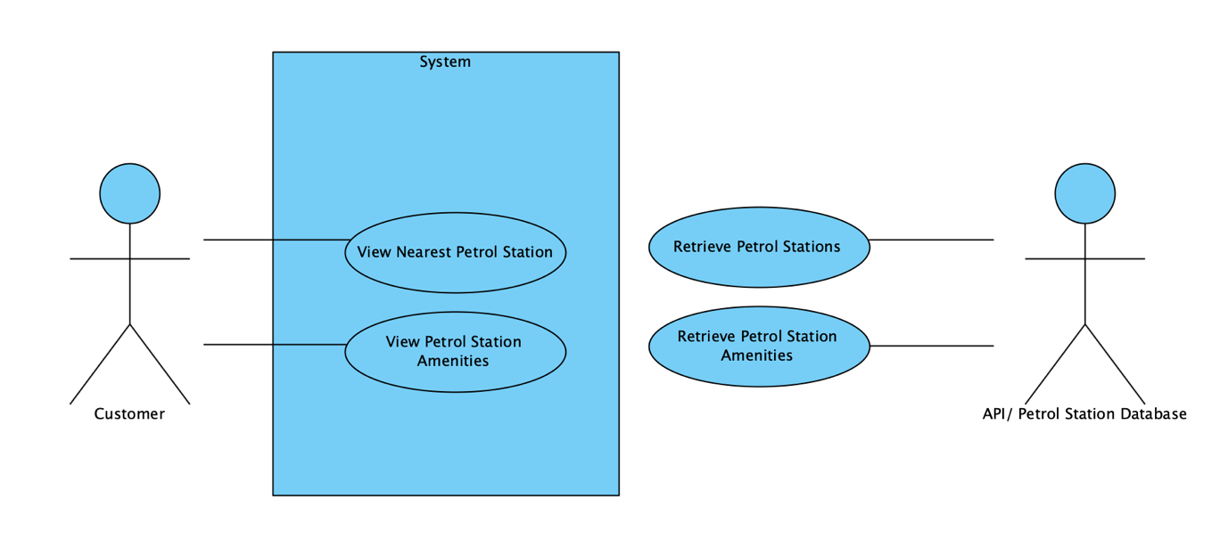***Use Cases Diagram:***

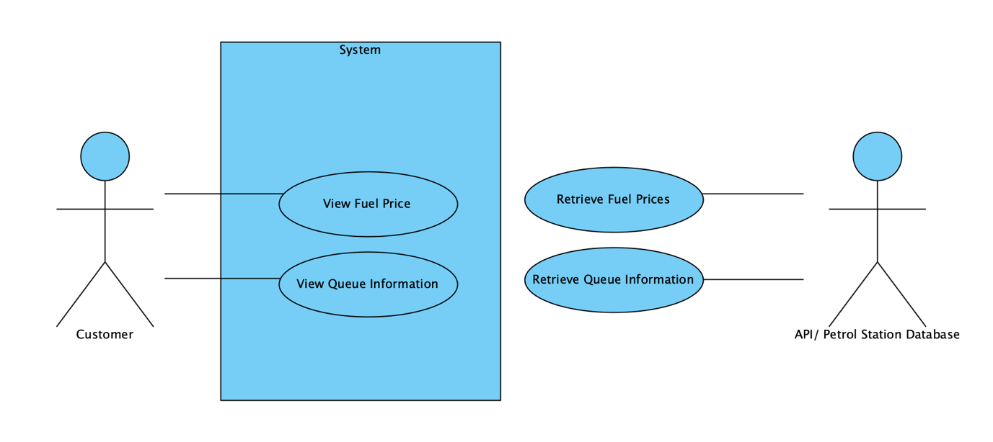

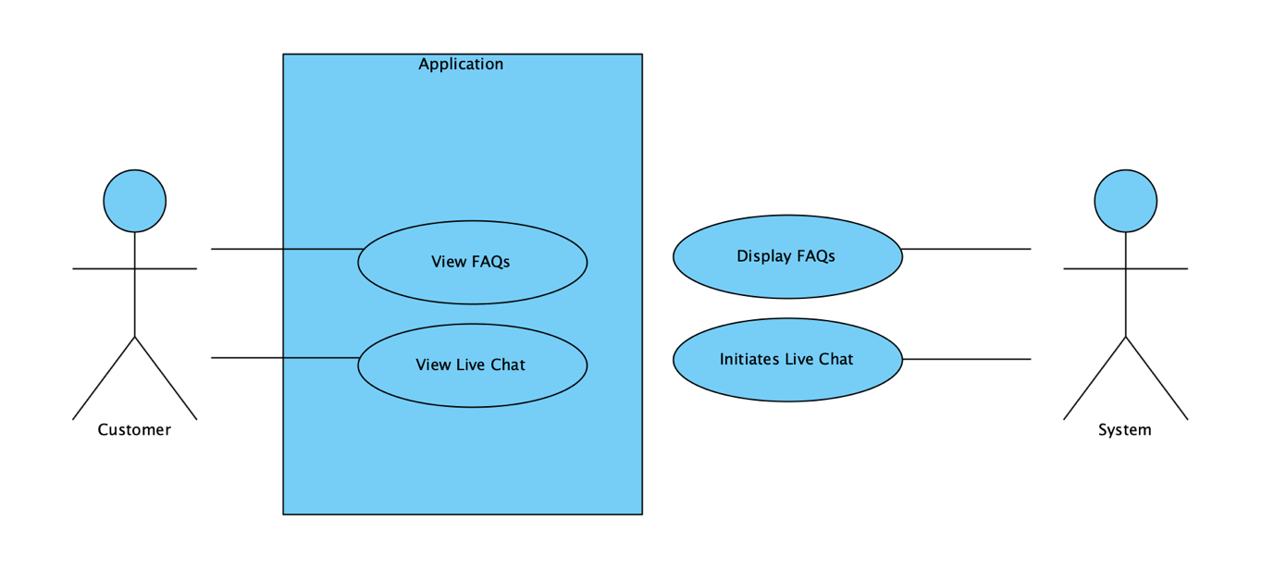

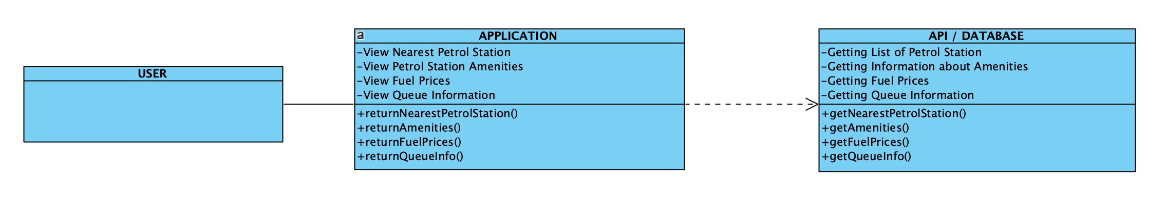***Class Diagram:***

***Activity Diagram:***

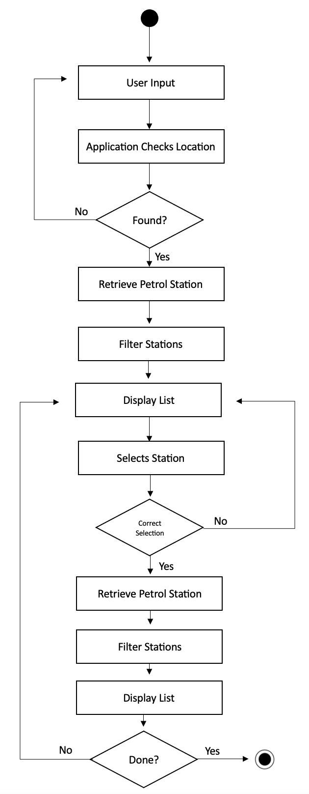

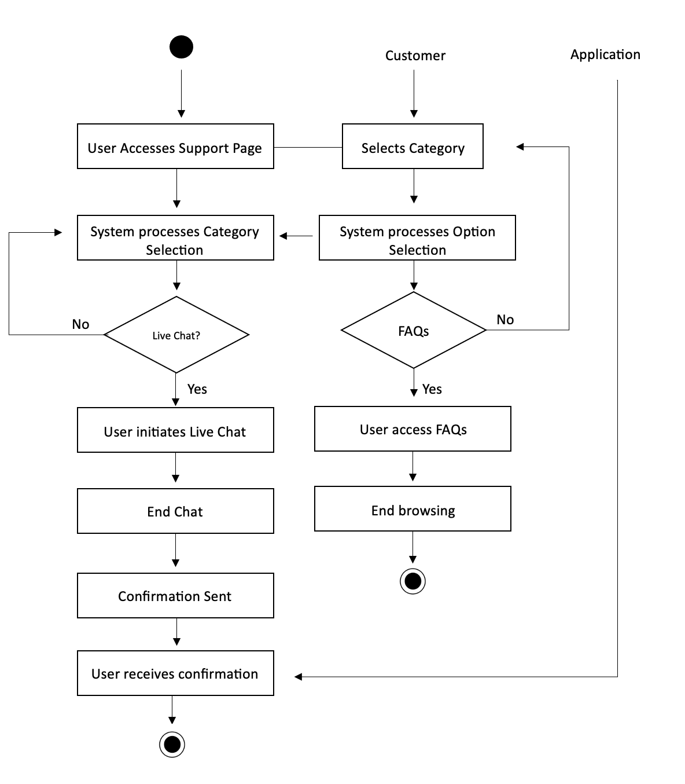

***Sequence Diagram:***

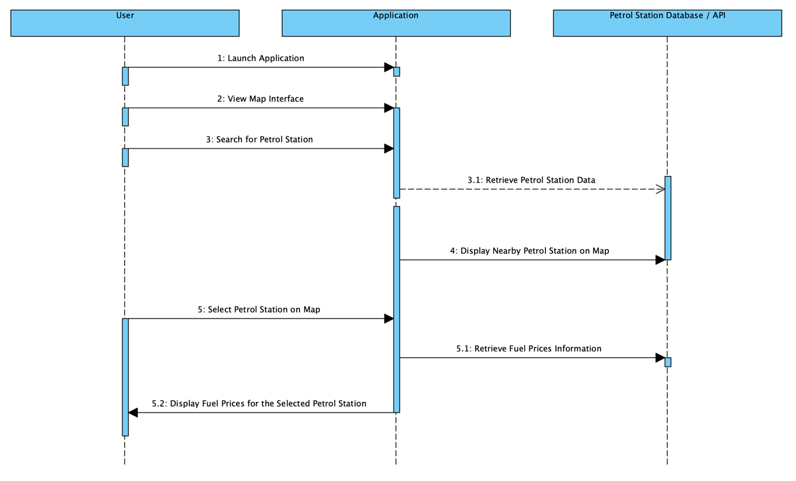

***Package Diagram:***

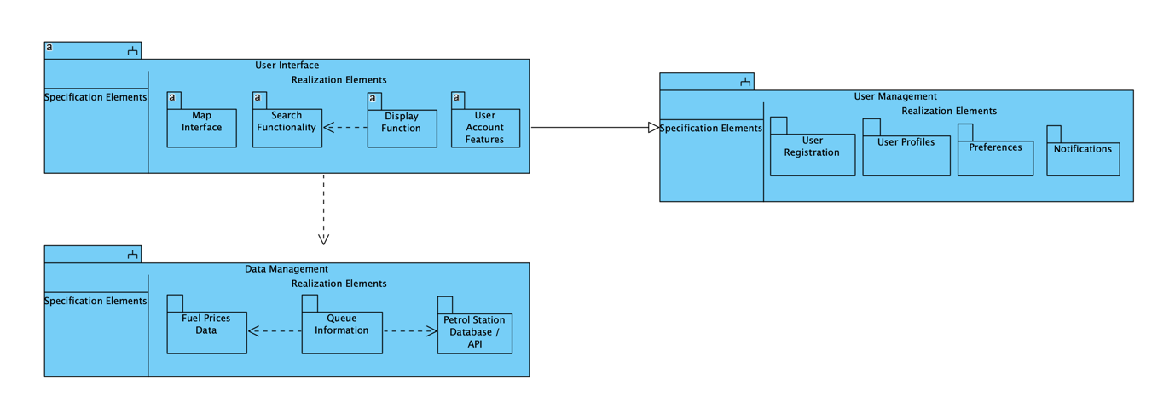

***Component Diagram:***

